Daisy-Chained Sensor Suite
Hardware Reference Manual
Revision 1.0
10/13/26
Jaxon Parriott


Table of Contents
Table of Contents 1
Board Overview 2
Block Diagram 2
Design Goals 2
Relevant Components 3
Extra Sections 5
Further sections that are needed for clarification or documentation 5
SPI Connectors Pinout 6
Engineering Change Orders 7
Revision XXX 7
Appendix A: Schematics 8
Appendix B: Manufactured Board Status 9
Appendix C-Onwards: Extra Info 10

Board Overview

Block Diagram


Design Goals
- Receive input SPI from a previous board and output SPI to the next board to form a daisy chain to send an information packet down.
  - Power only from the first in the chain
- Micro USB programming and Powering
  - Power MUX input from SPI and USB
  - Reverse voltage protection on SPI
  - 5v -> 3.3v Board voltage
- I2C Sensors (Separate I2C buses each)
  - IMU
  - Color Sensor
  - Hall Effect
  - Temperature Sensor
  - GPIO Expanded DIP switch
  - PWM LED Array
- Test Points for important signals/voltages
- 4 Mounting Holes (M2)

Relevant Components
- MCU
  - RP2040
    - 2 MB external Flash memory (W25Q16JVUXIQ TR) datasheet
    - 12 MHz Crystal (ABM8-272-T3) datasheet
    - Reset and Boot buttons (SKRPABE010) datasheet
    - TODO
- I2C Sensors
  - IMU
    - ICM-42605 datasheet
    - TODO
  - Color Sensor
    - VEML3328 datasheet
    - TODO
  - Hall Effect
    - TMAG5273C1QDBVR datasheet
    - TODO
  - Temperature Sensor
    - LM75ADP datasheet
    - TODO
  - GPIO Expander
    - TCA9534PWR datasheet
    - DIP Switch (DS01C-254-L-08BE) datasheet
    - Resistor Network (YC158TJR-0710KL) datasheet
    - TODO
  - LED Controller
    - IS31FL3254-QFLS4-TR datasheet
    - 8x RGB LEDS (CLMVC-FKA-CL1D1L71BB7C3C3) datasheet
    - TODO
- Connectors
  - Micro USB
    - 10118194-0001LF datasheet
    - TODO
  - SPI
    - S6B-PH-K-S datasheet
    - TODO
- Power
  - 3.3V Linear Regulator
    - AP2112K-3.3 datasheet
    - TODO
  - Power MUXing Diodes
    - LM66100DCK datasheet
    - TODO
- Debug
  - General Purpose LEDs (3)
    - 0603 LEDs datasheet (might need to look more into this)
    - TODO
  - General Purpose Buttons (2)
    - SKRPABE010 datasheet
    - TODO
    - DEBOUNCED

Extra Sections

Further sections that are needed for clarification or documentation
Examples:
- Pinouts
- High level section descriptions
- Design recommendations for firmware/software
- Expected use cases

Try to be descriptive but not excessive.
A good example (and what this is based on in general) can be found here.

SPI Connectors Pinout
Main spreadsheet can be found at this link.
Pin Number | Direction | Pin Type | Pin Function | Description
1 | IN | GND | Ground Reference | Ground Reference
2 | IN | 5V IN | 5V Input | 5V from previous board
3 | IN | SPI | SPI0 SCK | Master SPI Clock Input
4 | IN | SPI | SPI0 TX | SPI Data Out, MISO (Master In, Slave Out) with respect to prev board
5 | IN | SPI | SPI0 RX | SPI Data In, MOSI (Master Out, Slave In) with respect to prev board
6 | IN | SPI | SPI0 CSN | Master SPI Chip Select, Active Low
6 | OUT | GND | Ground Reference | Ground Reference
5 | OUT | 5V OUT | 5V Output | 5V to next board
4 | OUT | SPI | SPI1 SCK | Slave SPI Clock Output
3 | OUT | SPI | SPI1 TX | SPI Data Out, MISO (Master In, Slave Out) with respect to current board
2 | OUT | SPI | SPI1 RX | SPI Data In, MOSI (Master Out, Slave In) with respect to current board
1 | OUT | SPI | SPI1 CSN | Slave SPI Chip Select, Active Low
*OUT must match IN when aligned face to face.
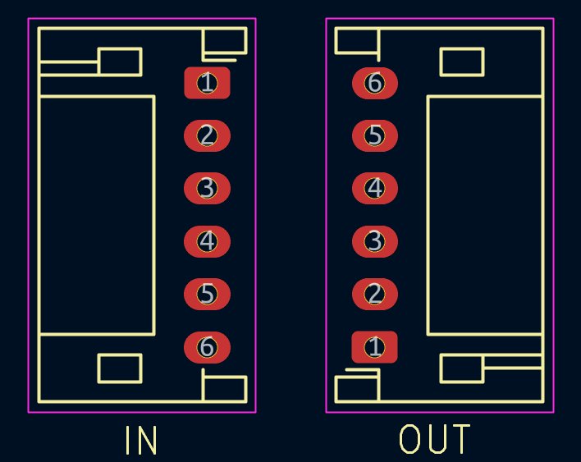

Engineering Change Orders
Any modifications made post-manufacture are documented here.

Revision XXX
Include detailed description of any and all changes per each revision.

Appendix A: Schematics
Links to schematics for the board(s).

Appendix B: Manufactured Board Status
Keep track of the status of all the boards here, a spreadsheet is recommended.

Appendix C-Onwards: Extra Info
Include any further info needed that is either not needed for general design or is included after the fact in further appendices.

